**Linux Environment Variable Assignment**

**1. State the command for the following.**

**a. view current environment variables**

**Ans:**

**printenv or env** command displays all current environment variables and their values.

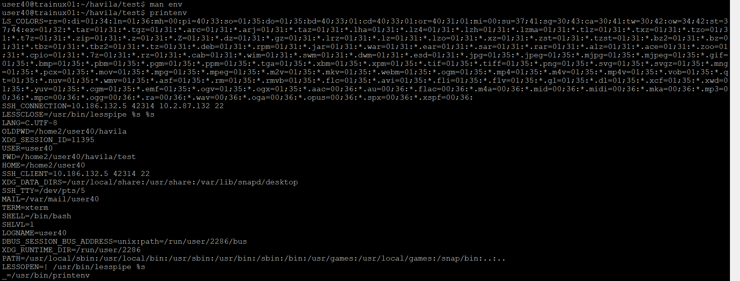

**b. display the PATH environment variable value**

**echo $PATH** shows the directories currently included in the PATH variable.



**c. update PATH to include the path to your home directory**

**export PATH=$PATH :$HOME**

This append your home directory to the PATH variable for the current session

**2. How will you make the environment changes applicable to all users? Which script is to be modified?**

To make environment changes (like modifying PATH) applicable to all users we need to edit the system wide profile script .This can be done by adding the export command to **/etc/profile** or a script in **/etc/profile.d/**

**For example:**

sudo nano /etc/profile

add the line :

export PATH=$PATH:/path/to/directory

after saving this change will apply to all users upon logging in.

**3. I have installed an application named “myapp”. After installation, if I invoke the application, it fails with error as “Command myapp not found”. How will you fix this**

**Ans:** If we get the error “command myapp not found” after installing myapp, its likely because the directory containing myapp isn’t in your PATH.

Steps to fix it :

1.find the installation path of myapp,for example ,/usr/local/myapp/bin.

2.add directory to your path:

Export PATH =$PATH: /usr/local/myapp/bin

3. to make this change permanent ,add the export line to your profile file:

Echo ‘export PATH=$PATH: /usr/local/myapp/bin’ >> ~/.bashrc

Or for all users :

Sudo echo ‘export PATH=$PATH: /usr/local/myapp/bin’ >> /etc /profile

4. reload the profile file or restart the terminal :

Source ~/.bashrc